**Blockchain-Enabled Management of SCRA Benefits: Enhancing Security, Transparency, and Efficiency for ServiceMembers**

Author: Kaustav Das

# Executive Summary

The Servicemembers Civil Relief Act (SCRA) provides vital financial and legal protections to active-duty servicemembers, including reduced loan interest rates, foreclosure protection, and deferred tax payments. The current system for managing SCRA benefits is inefficient, error-prone, and fragmented, leading to delays, data inconsistencies, and potential fraud. These issues are primarily due to outdated, manual processes and fragmented operations across multiple financial institutions and government agencies. This results in delays, errors, data inconsistencies, and potential fraud, which can lead to undue financial stress for servicemembers.

This white paper proposes a blockchain-based solution to address these challenges by creating a secure, transparent, and efficient platform for managing SCRA benefits through a consortium of financial institutions. The proposed solution leverages a permissioned blockchain and smart contracts to automate and streamline the verification, approval, and disbursement processes while enhancing data security and transparency.

**Key Benefits:**

* **Enhanced Security**: Immutable records and cryptographic protection ensure data integrity and prevent unauthorized alterations, safeguarding sensitive servicemember information.
* **Increased Transparency and Trust**: Auditable, transparent transactions build trust among servicemembers and financial institutions, ensuring accountability and regulatory compliance.
* **Operational Efficiency**: Automation of benefit verification and disbursement reduces administrative overhead and speeds up the entire process, ensuring timely support for servicemembers.
* **Data Integrity and Accessibility**: Secure data storage solutions, including off-chain methods, ensure data integrity and provide easy access for managing benefits, even remotely.

By leveraging the strengths of blockchain technology and consortium management, this solution significantly improves the administration of SCRA benefits, offering a robust and scalable approach that benefits all stakeholders involved.

# Introduction

The Servicemembers Civil Relief Act (SCRA) offers essential financial and legal safeguards for active-duty servicemembers. Designed to ease financial pressures on servicemembers, the SCRA provides advantages such as lower interest rates on loans obtained before service, safeguards against foreclosure, and the ability to postpone income tax payments. These provisions aim to enable servicemembers to concentrate on their military responsibilities without excessive financial strain.

Financial institutions are legally required to offer these benefits to eligible servicemembers. Under SCRA, institutions must cap interest rates for pre-service debts, prevent foreclosure on active-duty personnel, and ensure protection against default judgments. Compliance with these mandates is overseen by regulatory bodies such as the Department of Justice (DOJ) and the Consumer Financial Protection Bureau (CFPB), which ensure that servicemembers receive the benefits they are entitled to by law.

The current system for managing Servicemembers Civil Relief Act (SCRA) benefits is fraught by several inefficiencies and risks, which underscore the urgent need for a more secure, transparent, and efficient solution. One of the primary issues is the reliance on manual processes and outdated systems, which are prone to errors and delays. For example, verifying a servicemember’s eligibility for benefits often involves cumbersome paperwork and prolonged processing times, leading to delays in benefit disbursement and unnecessary financial strain on servicemembers and their families​.

Moreover, the fragmented nature of the current system, where multiple financial institutions and government agencies operate in silos, exacerbates these inefficiencies. This fragmentation not only makes it difficult to track and verify benefit claims but also increases the risk of data inconsistencies and fraud. Without a unified and secure platform, maintaining the integrity and accuracy of SCRA benefit records is a significant challenge​.

Data security is another critical concern. Traditional systems often lack robust encryption and security protocols, making sensitive information vulnerable to breaches and unauthorized access. Given the highly sensitive nature of military personnel data, any compromise can have severe repercussions, both financially and personally, for the servicemembers involved​​. Additionally, the lack of transparency in the current system makes it difficult to audit and verify transactions, leading to potential compliance issues and undermining trust among stakeholders​​.

To address these issues, there is a compelling need for a secure, transparent, and efficient solution. Blockchain technology offers a promising remedy by providing an immutable and transparent ledger for recording SCRA benefits. A blockchain-based platform can streamline verification processes through smart contracts, which automate the approval and disbursement of benefits based on predefined criteria. This automation not only reduces administrative overhead but also ensures timely and accurate benefit distribution. Furthermore, blockchain’s decentralized nature enhances data security by storing encrypted data across multiple nodes, reducing the risk of unauthorized access and data breaches. By implementing a blockchain-enabled solution, financial institutions can significantly improve the management of SCRA benefits, ensuring servicemembers receive the support they need promptly and securely​​.

# Proposed Solution

The proposed solution automates the verification, disbursement, and audit of SCRA benefits using smart contracts on a permissioned blockchain. The following is an overview of the key processes and its components:

## High Level Overview

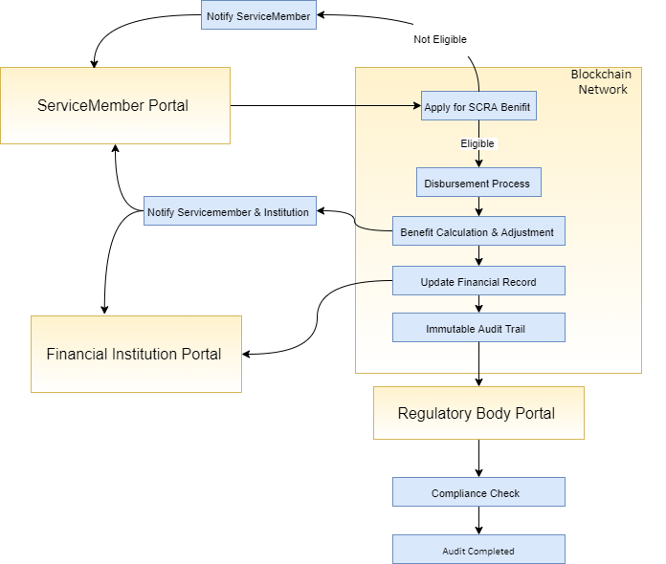

Figure 1: Blockchain Enabled Management of SCRA Benefit High Level Workflow

1. **Servicemember Applies for SCRA Benefits**

* **Servicemember Portal**: A servicemember logs into the portal and applies for SCRA benefits.

1. **Verification Process**

* **Smart Contract Verification**: A smart contract automatically initiates the verification process once the application is submitted.
* **Eligibility Check**: The smart contract cross-references the servicemember’s military records stored in off-chain databases (like centralized databases or InterPlanetary File System [IPFS]) to verify eligibility.
* **Outcome**:
  + **If Eligible**: The process moves to the disbursement stage.
  + **If Not Eligible**: The servicemember is notified that they do not qualify for the benefits.

1. **Disbursement Process**

* **Benefit Calculation and Adjustment**: For eligible servicemembers, the smart contract calculates the specific benefits, such as interest rate reductions or fee waivers, based on predefined rules.
* **Automatic Adjustment**: These benefits are applied to the servicemember’s financial records stored on the blockchain.
* **Notification**: Both the servicemember and the financial institution receive a notification confirming the adjustments made.

1. **Updating Financial Records**

* **Blockchain Update**: The smart contract updates the servicemember’s financial records on the blockchain, ensuring secure recording of all adjustments.
* **Immutable Audit Trail**: All transactions and adjustments are stored on an immutable ledger as part of the blockchain.

1. **Regulatory Body Access and Compliance Check**

* **Regulatory Body Portal**: Regulatory bodies, like the Department of Justice or Consumer Financial Protection Bureau, can access the blockchain via a dedicated portal.
* **Audit Trail Review**: These bodies can review the immutable audit trail to ensure all transactions comply with SCRA regulations.
* **Compliance Check**: If compliant, the process concludes with an audit report; otherwise, necessary actions are taken.

## Solution Components

**Consortium Model**

* **Participants**: Includes multiple financial institutions, regulatory bodies, and potentially military organizations.
* **Governance**: Managed by a governing body consisting of representatives from participating entities, responsible for establishing rules, managing permissions, and ensuring compliance.
* **Consensus Mechanism**: Utilizes Practical Byzantine Fault Tolerance (PBFT) or modified Proof of Authority (PoA) to validate transactions and ensure network security without energy-intensive processes.

**Permissioned Blockchain**

* **Access Control**: Only authorized nodes (financial institutions, regulatory bodies, military organizations) can participate, ensuring controlled access.
* **Transparency and Privacy**: Transaction details are visible to authorized participants, while sensitive information is encrypted to protect privacy.
* **Immutable Ledger**: All transactions and data entries are recorded on an immutable ledger, providing a tamper-proof record.

**Smart Contracts for Automation**

* **Verification**:
  + **Eligibility Check**: Automatically verifies servicemembers' eligibility by cross-referencing military records stored on the blockchain.
  + **Continuous Monitoring**: Smart contracts periodically update eligibility status to ensure ongoing benefits for qualified servicemembers.
* **Disbursement**:
  + **Automatic Adjustments**: Smart contracts automatically apply benefits, such as interest rate reductions or fee waivers, upon verification.
  + **Notifications**: Real-time notifications are sent to servicemembers and financial institutions about adjustments and transactions.
* **Audit and Compliance**:
  + **Audit Trails**: Every action is recorded on the blockchain, providing an auditable trail for regulatory review.
  + **Compliance Checks**: Smart contracts enforce compliance with SCRA regulations, reducing the risk of non-compliance.

## Technical Architecture

Below is the proposed technical architecture of the proposed solution.

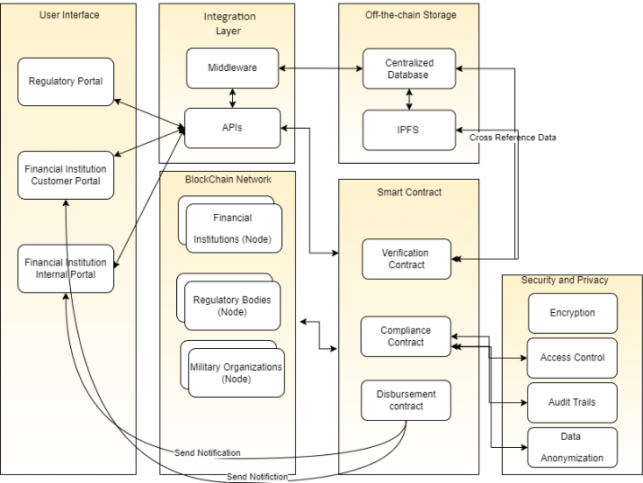

Figure 2: Technical Architecture

Below are a detailed description of the system’s components and their interactions:

**User Interfaces:**

* **Financial Institution Customer Portal**: Provides service members with access to their data, enabling them to enter information and track their benefits.
* **Financial Institution Internal Portal:** Allows financial institutions to interact with the blockchain system for benefit processing and record management.
* **Regulatory Body Portal:** Grants access to audit trails and compliance reports for regulatory oversight and enforcement.

**Blockchain Network:**

* **Nodes**: Includes Financial Institutions, Regulatory Bodies, and Military Organizations, each participating in the blockchain network.
* **Consensus Mechanism:** 
  + **Practical Byzantine Fault Tolerance (PBFT):** Ensures high transaction throughput and low latency, suitable for permissioned networks. PBFT can handle thousands of transactions per second while maintaining responsiveness under high load.
  + **Modified Proof of Authority (PoA):** Employs a select number of trusted nodes for transaction validation, enhancing efficiency and expediting transaction processing.

**Smart Contracts:**

* **Verification**: Automates eligibility verification.
* **Disbursement**: Manages benefit adjustments.
* **Compliance**: Ensures regulatory compliance and maintains audit trails.

**Off-Chain Data Storage:**

* **InterPlanetary File System (IPFS)**: Provides decentralized storage for large datasets, enhancing data availability and resilience.
* **Centralized Databases**: Offers high-security storage for sensitive information, ensuring data protection and integrity.
* **Data Management**: Utilizes cryptographic hashes to ensure data integrity and establish secure linkages between on-chain and off-chain data.

**Integration Layer:**

* **APIs**: Facilitates seamless communication between various system components.
* **Middleware:** Manages data translation, formatting, and transfer, ensuring compatibility across different systems and components.

**Security and Privacy:**

* **Encryption**: Protects data in transit and at rest, safeguarding against unauthorized access.
* **Access Control**: Implements role-based access control to restrict system access based on user roles and responsibilities.
* **Audit Trails**: Maintains immutable records of all transactions and interactions, providing transparency and accountability.
* **Data Anonymization**: Ensures user privacy by anonymizing sensitive data where possible.

**Scalability and Performance**

To address scalability and performance challenges, the solution incorporates several strategies:

* **Sharding:** Splitting the blockchain into smaller, manageable pieces called shards, each capable of processing transactions independently. This approach increases overall transaction capacity.
* **Off-Chain Data Storage:** Uses IPFS or centralized databases to alleviate the on-chain data load, enhancing system performance and scalability.
* **Load Balancing:** Employs advanced techniques to distribute transaction processing evenly across nodes, preventing bottlenecks and maintaining consistent performance.
* **Monitoring and Optimization:** Continuously monitors metrics such as transaction throughput, latency, and resource utilization. Ongoing system optimization addresses performance bottlenecks and ensures smooth operation.

**Consortium Management**

Effective consortium management is crucial for the successful operation of the blockchain solution. The governance model includes the following elements.

**Decision-Making Process:**

* **Voting Mechanism:** Decisions within the consortium are made through a voting process, where each member institution casts a vote. The weight of each vote may be equal or based on criteria such as institutional size or network role.
* **Consensus-Based Decisions:** Critical decisions require a supermajority (e.g., 2/3 or 3/4 majority) to ensure broad agreement among consortium members.

**Conflict Resolution:**

* **Mediation Committee**: A mediation committee, consisting of representatives from diverse consortium members, resolves conflicts by reviewing disputes, facilitating discussions, and proposing solutions.
* **Arbitration Process**: If mediation fails, an arbitration process involving an impartial third party will make binding decisions to resolve conflicts.

**Onboarding New Participants (Nodes)**

* **Application Process**: Prospective members undergo a formal application process, which includes evaluating their technical capabilities, regulatory compliance, and alignment with the consortium’s goals.
* **Approval Process**: New members are approved through a vote by existing consortium members to ensure that only reputable and compliant institutions join the network.
* **Integration Support:** New participants receive technical assistance and training to ensure seamless integration into the blockchain network.

**Governance Structure:**

* **Steering Committee:** Oversees the consortium’s overall direction, including strategic planning, policy development, and performance monitoring.
* **Technical Working Groups:** Specialized groups focus on areas such as security, compliance, and technological advancements, providing recommendations and implementing improvements.

# Use Cases

1. **Automated Eligibility Verification**

The current system for verifying servicemembers' eligibility for SCRA benefits is manual, time-consuming, and prone to errors. A blockchain-backed solution employs smart contracts to automatically verify eligibility by cross-referencing military service records stored off-chain. This ensures that eligibility determinations are accurate and timely, significantly reducing administrative overhead and minimizing the risk of human error. The automated nature of smart contracts means that servicemembers' benefits are processed more efficiently, providing them with the support they need without unnecessary delays.

1. **Seamless Transfer of Benefits Between Financial Institutions**

Transferring SCRA benefits between financial institutions is often a cumbersome and inefficient process. When servicemembers shift their accounts, the manual verification and transfer of benefits can result in delays and inaccuracies. By utilizing a consortium blockchain, a unified and immutable record of SCRA benefits is maintained across all participating institutions. Smart contracts facilitate the seamless transfer of benefits by automatically verifying eligibility and updating records as servicemembers move their accounts. This streamlined process ensures that servicemembers' benefits are accurately transferred and maintained, enhancing operational efficiency, and reducing delays.

1. **Enhanced Security and Data Integrity SCRA and Service Member Records**

Centralized systems are vulnerable to data breaches and unauthorized access, posing significant risks to sensitive servicemember data. A blockchain-based solution enhances security and data integrity through its decentralized nature and cryptographic protection. Data is stored off-chain in centralized or decentralized storage solutions, with cryptographic hashes recorded on the blockchain to ensure integrity and prevent tampering. This approach significantly reduces the risk of centralized data breaches and unauthorized alterations, providing robust security and ensuring that servicemember records are protected.

1. **Improve Transparency and Trust in Benefit Disbursement**

The current system's lack of transparency leads to trust issues and difficulties in auditing transactions. Blockchain technology offers a transparent and immutable ledger where all transactions and benefit disbursements are recorded. This ensures that all actions are visible and easily auditable by regulatory bodies, fostering trust among servicemembers and financial institutions. The transparent nature of the blockchain provides a verifiable and tamper-proof record of all activities, making it easier to ensure compliance with SCRA regulations and build confidence in the system.

1. **Efficient Disbursement of SCRA Benefits**

Manual processes for adjusting interest rates and other SCRA benefits are slow and inefficient. A blockchain-backed solution utilizes smart contracts to automate the disbursement of benefits. These smart contracts can automatically adjust interest rates, apply fee waivers, and provide other benefits based on verified eligibility data. By automating these processes, the solution significantly reduces processing times and administrative burdens, ensuring that servicemembers receive their benefits promptly and accurately.

1. **Regulatory Compliance and Audit Trails**

Ensuring compliance with SCRA regulations and maintaining accurate audit trails is complex and resource-intensive in the current system. A blockchain-based solution enforces compliance through smart contracts, which ensure that all actions conform to SCRA regulations. The blockchain provides an immutable audit trail of all transactions and benefit adjustments, making it easier for regulatory bodies to audit the system and ensure compliance. This approach simplifies the compliance process, reduces the risk of non-compliance, and provides clear and verifiable audit trails for regulatory oversight.

1. **Data Accessibility for Servicemembers**

Servicemembers often face difficulties accessing and managing their benefits, especially when deployed or relocated. A decentralized blockchain network allows servicemembers to securely access and manage their benefits from any location using their cryptographic keys. This enhances servicemembers' ability to manage their benefits, providing better financial control and support. The decentralized nature of the blockchain ensures that servicemembers can easily and securely access their records, regardless of their location, improving overall accessibility and convenience.

# Conclusion

The implementation of a blockchain-enabled system for managing SCRA benefits ensures secure, transparent, and efficient administration for service members. By utilizing blockchain technology, smart contracts, and consensus mechanisms like PBFT and Modified PoA, the system overcomes challenges in traditional benefit management.

The architecture integrates user interfaces, a blockchain network, off-chain storage, and an integration layer for a secure and seamless experience. Scalability and performance are enhanced through sharding, off-chain storage, and Layer 2 solutions, allowing the system to adapt to increasing demands.

Effective consortium management, with a clear governance model and structured onboarding, ensures smooth operations and continuous improvement. The proposed system offers a resilient solution, meeting the needs of all stakeholders while setting a new standard for benefits management.

# References

**Bank of America and Blockchain Technology**

* Bank of America advances with AI and blockchain in digital push (no date) *Investing.com*. Available at: <https://in.investing.com/news/bank-of-america-advances-with-ai-and-blockchain-in-digital-push-93CH-3985505> (Accessed: 22 July 2024).

**HSBC and Blockchain Integration**

* HSBC Blockchain Initiatives: Revolutionizing Trade Finance (no date) *HSBC Business*. Available at: <https://www.business.hsbc.ae/en-gb/campaigns/blockchain> (Accessed: 22 July 2024).

**JPMorgan's Quorum Blockchain**

* JPMorgan's Quorum: Leveraging Blockchain for Financial Services (no date) *JPMorgan*. Available at: <https://www.jpmorgan.com/content/dam/jpm/cib/complex/content/investment-banking/blockchain/pdf-0.pdf> (Accessed: 22 July 2024).

**American Express Blockchain Projects**

* American Express and Blockchain: Enhancing Payment Security (no date) *American Express*. Available at: <https://www.americanexpress.com/us/foreign-exchange/articles/blockchain-to-accelerate-payment-processing-services/> (Accessed: 22 July 2024).

**Technical References**

**InterPlanetary File System (IPFS)**

* Understanding IPFS: A Peer-to-Peer Hypermedia Protocol (no date) *IPFS*. Available at: <https://ipfs.tech/> (Accessed: 03 Aug 2024).

**Hyperledger Fabric Overview**

* Hyperledger Fabric: A Distributed Ledger Technology (no date) *Hyperledger*. Available at: <https://www.hyperledger.org/> (Accessed: 03 Aug 2024).

**Practical Byzantine Fault Tolerance (PBFT)**

* PBFT: An Efficient and Practical Tolerance Algorithm (2024) *IEEE Xplore*. Available at: <https://ieeexplore.ieee.org/stamp/stamp.jsp?arnumber=9718319> (Accessed: 03 Aug 2024).

**Smart Contracts: Automation and Compliance**

* Blockchain-Enabled Smart Contracts: Architecture, Applications, and Future Trends (no date) *HAUT*. Available at: <http://dcbcl.haut.edu.cn/ups/files/20210416/1618537662240906.pdf> (Accessed: 03 Aug 2024).

**Legal References**

**Servicemembers Civil Relief Act (SCRA)**

* Servicemembers Civil Relief Act (SCRA) - Protecting Those Who Protect Us: Evidence of Activated Guard and Reserve Usage of SCRA (no date) *Consumer Financial Protection Bureau*. Available at: <https://www.consumerfinance.gov/data-research/research-reports/evidence-of-servicemembers-usage-of-credit-protections-under-scra/> (Accessed: 22 July 2024).
* Servicemembers' Civil Relief Act (SCRA) - MyArmyBenefits (no date) *MyArmyBenefits*. Available at: <https://myarmybenefits.us.army.mil/Benefit-Library/Federal-Benefits/Servicemembers-Civil-Relief-Act-(SCRA)> (Accessed: 22 July 2024).
* Servicemembers Civil Relief Act (SCRA) & VA Loans (no date) *U.S. Department of Veterans Affairs*. Available at: <https://benefits.va.gov/HOMELOANS/scra.asp> (Accessed: 22 July 2024).